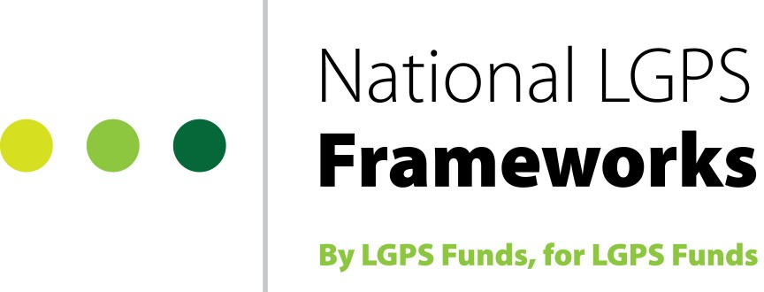

National LGPS Framework for Global Custody Services -

Option Form

Please complete either Option 1 or Option 2 below, then return this form to:
NationalLGPSFrameworks@norfolk.gov.uk
Option 1: I would like to see the Guidance notes, Terms and Conditions and
Provider Catalogues before I go any further.

Before we send you this commercially sensitive information, we need a signed Confidentiality Statement from you. Once we receive this, we can forward the Framework documentation to you.

Please send the details to (name).…………………………………………………………….
☐I have enclosed a signed copy of the Confidentiality Statement
Email address…………………………………………Tel:……………………………………..

Option 2: I would like to use the framework.

☐Please send me a copy of the Members Access Agreement to sign

☐I have enclosed a signed copy of the Confidentiality Statement

Or
☐I have previously signed a copy of the Confidentiality Statement

Please send the Members Access Agreement and Framework documentation to: (name)…………………………………………………………………………………………….
Email address…………………………………………Tel:……………………………………..

Please send the invoice for the Joiners Fee to: (name)………………………………………

Invoice address………………………………………………………………………………………

……………………………………...Telephone number…………………………...

Last updated: August 2021

