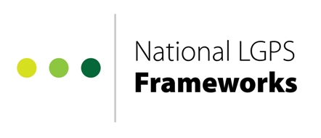
Form Instructions
Notification of a Contract Award under a National LGPS Framework
Contract Award Notification Form

As the letting authority of the National LGPS Frameworks, we must be notified of all contracts awarded under each Framework Agreement. This includes every Direct Award and Further Competition, even if it is made to the same Provider as a previous contract.

Submitting this form allows us to monitor all appointments made via the Frameworks for performance and spend, along with ensuring, where applicable, you receive any Cumulative Rebate you may be entitled to.

Once your Order Form has been signed by both parties:
- Complete this notification form
- Return it to the National LGPS Frameworks team at nationalLGPSframeworks@norfolk.gov.uk

Contract Award Notification Form

Framework Contract Award Details

Contracting authority / organisation details

Contracting Authority / Organisational name
Contact name
Contact telephone number
Contact email

Contract details and Provider appointment

Framework (Select from drop down list) | Choose an item.
Lot used (if applicable)
Appointed Provider(s)
Procurement type
e.g. Further Competition or Direct Award
Contract Commencement Date
Contract Expiry Date
Option to extend? (Please detail any possible extension period)
Estimated Contract Value

Contract Notices

Please confirm that any relevant award notices have been published in accordance with the regulations which govern this Framework. | Y/N
Link to Notices

Feedback
We are always trying to improve the National LGPS Frameworks and any feedback you can provide below (positive and negative) would be most appreciated.

Further Information and Questions

If you need any further information or have any questions please contact the National LGPS Frameworks team at nationalLGPSframeworks@norfolk.gov.uk or call 01603 306846.

